**BX3083: STRATEGIC MARKETING**

|  |
| --- |
| Strategic Marketing |

|  |
| --- |
| BX3083 |

|  |
| --- |
| BX3083 |

|  |
| --- |
| BX3083 |

ASSESSMENT TASK 2 COLLEGE OF BUSINESS, LAW AND GOVERNANCE



**INDIVIDUAL TASK COVER SHEET**

|  |  |  |  |  |  |  |  |  |  |
| --- | --- | --- | --- | --- | --- | --- | --- | --- | --- |
| *Student*  *Please sign, date and attach cover sheet to front of assessment task for all hard copy submissions* | | | | | | | | | |
| **SUBJECT CODE** | BX3083 | | | | | | | | |
| **STUDENT FAMILY NAME** | **Student Given Name** | **JCU Student Number** | | | | | | | |
| Tran | Le Binh | 1 | 3 | 4 | 7 | 6 | 1 | 1 | 2 |
| **ASSESSMENT TITLE** | Proposal | | | | | | | | |
| **DUE DATE** | 27 Nov 2018 | | | | | | | | |
| **LECTURER NAME** | Val Philip Ortega | | | | | | | | |
| **TUTOR NAME** | Val Philip Ortega | | | | | | | | |
| **Student Declaration**   1. This assignment is my original work and no part has been copied/ reproduced from any other person’s work or from any other source, except where acknowledgement has been made (see *Learning, Teaching and Assessment Policy 5.1*). 2. This work has not been submitted for any other course/subject (see *Learning, Teaching and Assessment Policy 5.9*). 3. This assignment has not been written for me. 4. I hold a copy of this assignment and can produce a copy if requested. 5. This work may be used for the purposes of moderation and identifying plagiarism. 6. I give permission for a copy of this marked assignment to be retained by the College for benchmarking and course review and accreditation purposes.   [Learning, Teaching and Assessment Policy](http://www.jcu.edu.au/policy/allitoz/JCU_076643.html) 5.1. A student who submits work containing plagiarised material for assessment will be subject to the provisions of the [Student Academic Misconduct Requirements.](http://www.jcu.edu.au/policy/allitoz/JCUDEV_005375.html)  **Note definition of plagiarism and self plagiarism in Learning, Teaching and Assessment Policy:**  **Plagiarism:** reproduction without acknowledgement of another person’s words, work or expressed thoughts from any source. The definition of words, works and thoughts includes such representations as diagrams, drawings, sketches, pictures, objects, text, lecture hand-outs, artistic works and other such expressions of ideas, but hereafter the term ‘work’ is used to embrace all of these. Plagiarism comprises not only direct copying of aspects of another person’s work but also the reproduction, even if slightly rewritten or adapted, of someone else’s ideas. In both cases, someone else’s work is presented as the student’s own. Under the Australian *Copyright Act 1968* a copyright owner can take legal action in the courts against a party who has infringed their copyright.  **Self Plagiarism:** the use of one’s own previously assessed material being resubmitted without acknowledgement or citing of the original.  **Student Signature**  Tran Le Binh Submission date 27/11/ 2018 | | | | | | | | | |

**BX3083: Strategic Marketing**



**Gong Cha Strategic Marketing Proposal**

Student name: Tran Le Binh

Lecture name: Val Philip Ortega

Date: 27/11/ 2018

**Table of Content**

1. Introduction 4

2. Company and micro-environment 5

2.1. Company description 5

2.2. SWOT analysis 5

2.3. Micro-environment 6

2.2.1. Competitors 6

2.2.2. Current position 7

2.2.3. Success of marketing strategies 7

2.2.3.1. Product 7

2.2.3.2. Promotion 7

2.2.3.3. Place 8

2.2.3.4. Price 8

3. Product/Service Analysis 8

3.1. Product analysis 8

3.2. Product life cycle 9

4. Target Market 9

5. Timeframe: Gantt Chart 10

6. Conclusion 10

**Table of Figure**

Figure 1: Gong Cha Competitors 6

Figure 2: Gong Cha Positioning Map 7

Figure 3: Product Layers 9

Figure 4: Gong Cha Product Life Cycle 9

Figure 5: Target Market Segmentation 10

# Introduction

Gong Cha has become the most favorite F&B brand in Singapore in 2013. This is a destination to enjoy the bubble tea with a several flavor of beverage. In fact, the business also contains some problems when operating the business in relation to service, experience, management, which is often seen on Tripadvisor, FoodPanda websites. There are some competitors bringing similar products about bubble tea. There are some potential risks that affect directly to the business like food hygiene and safety, customer feedbacks, market trend, weather, global economy, ingredient supply. Hence, the Gong Cha should recognize the market demand combining the macro, micro environment and innovate the solutions to become the sustainable business in the current tough competitive business landscape.

It is interesting to notice that Gong Cha just came back in December 2017 after existing in June 2017. Therefore, whether the saturation of bubble tea products in the market will affect the business when they re-opened the business or not? The marketing proposal for the Gong Cha will outline the business position, customers, the discrepancy between Gong Cha and competitors, detailed discovery about product and service analysis, micro-environment, timeframe. The aim of this marketing proposal is to develop the permanent strategic marketing plan in 3 years.

# Company and micro-environment

## Company description

The Gong Cha is famous for delivering the highest quality of tea in the world (Brand Story, 2018). There are about 17 outlets in Singapore and over 500 stores in Taiwan, Hong Kong, China, Philippines, Cambodia, Korea, USA, Indonesia and Malaysia (About Gong Cha, 2018). Gong Cha just came back Singapore in December, 2017 after existing in June, 2017.

The Gong Cha has successfully brought about the concept of offering best tea quality in Singapore not only for local people but also for foreigners. The mission contributing to the success of its business is to ensure the ingredient quality, followed by taste and flavor, satisfy he customers’ demands and establish the steady and innovative firm (Mission & Vision, 2018).

The vision is to become the reliable providers of tea quality in the world (Mission & Vision, 2018). Every tea batch must undergo the strict international SGS examination before processing the products. The water with purification standard is used to make ice cubes and drinks. This makes consumers assure about the food hygiene (Mission & Vision, 2018).

It is interesting to notice that during the second quarter of 2017 in Singapore, the business decided to transform the business brand into the LiHO brand, which marked the withdrawal from the business (Yahya, 2017). However, on 2nd December, 2017, Gong Cha brand came back after existing Singapore. This drew a significant attention in Singapore market through the queuing participation of more than 150 people at SingPost Centre (Tan, 2017). In 2017, the business gained about $30 million in revenue (Yahya, 2017).

## SWOT analysis

|  |  |
| --- | --- |
| Strengths   * Provide sitting space for customers * Provide quick service * Locate in shopping areas | Weaknesses   * Bad customer service * Poor service staff attitude at Marina Bay Sands |
| Opportunities   * Some outlets provide sitting space rather than KOI or LiHO * There are some self-service kiosks to provide quick service | Threats   * Competitors offer similar products * Cause milk tea addiction for young people |

## Micro-environment

### Competitors

|  |  |  |
| --- | --- | --- |
| Direct competitors | Indirect competitors | Replacement competitor |
| Become the market leader of Taiwanese bubble milk tea in operating the business   * LiHO * KOI | * Hollin uses homemade pearls to attract customers * Teafolia uses both fresh fruits and tea to process the products (The Teafolia Story, 2018). * Woobbee applies the method of serving premium and healthy tea and using raw sugar to process the products (About Woobbee, 2018). * R&B products use the finiest Oolong tea leaves, fresh fruit juices and all-natural ingredients to run the business (R&B Tea Singapore, 2018). * Bobii Frutti uses a slogan “Each Cup is an Art” to gain the desired revenue (The Ultimate Bubble Tea, 2018). * I Love Taimei use the message of delivering the flavor of love through passion and good food to increase the revenue (About Us, 2018). * Each-a-Cup uses a strategy “The goodness of each cup” to gain the revenue (Weight Lite, 2018). | The restaurants provide different forms of drinks to serve the customers in Singapore like soft drinks, Mojito, Cocktails, Mocktails. |

Figure : Gong Cha Competitors

### Current position

Due to the high competitive feature of the industry and competitors, the Gong Cha will be positioned as service and location. The utilization of self-service kiosks technology enhances business performance. However, this model just appears in some outlets like National University of Singapore’s U Town, SingPost Centre. The high standard drinks, service, ideal location are synthetic benefits compared to other competitors.

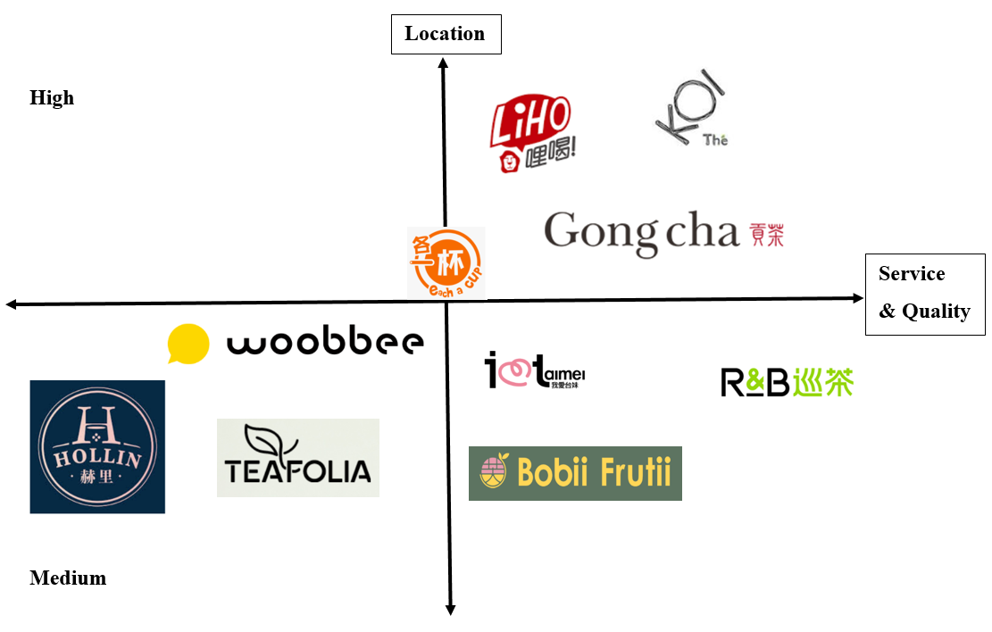

Figure : Gong Cha Positioning Map

### Success of marketing strategies

##### Product

The Gong Cha offers the high quality of each tea batch to customers. The business best seller product is knowns as Gong Cha Milk Foam Series, which combines the milk foam from Coffee Latte and the flavor of salt. The business provides a variety kind of beverage like Hot Drink, Milk Tea, Latte, Signature, Brewed Tea, Crafted Extract Tea, Refreshing Choice, and Creative Mix (Products, 2018).

##### Promotion

The Gong Cha has used lots of methods to promote the products like using Word-of-mouth strategy, Facebook, Instagram, business website and the primary stakeholder – DBS Bank which offers the discount price when the customers become the Gong Cha member and use payment method through PayLah until 19th January 2019 (News & Events, 2018). The firm uses online marketing communication which providing online feedback or enquiry. These channels help the customers directly express their feeling, experience about the products consumed at the outlet. This will help the firm obviously aware of their performance.

##### Place

The Gong Cha has about 17 outlets in Singapore. The clients can take the public transportation like bus or MRT, drive a private car or use GRAB to get there. The outlets are in the prime location such as Raffles Place, Bugis Junction, Century Square, NUS UTown, Eunos MRT, Compass One (COM), Northpoint (NP), Pasir Ris MRT (PRM), Plaza Sing (PZS), Simei MRT (SMM), Signpost (SP), SMU café 2.0 (SMU), Takashimaya (TAKA), Tan Tock Seng Hospital (TTSH), Toa Payoh (TPY), Westgate (WG). Woodlands MRT (WLM).

##### Price

The price of Gong Cha is competitive based on the competition. For instance, the flavors of milk tea worth about 3.20 SGD to 5 SGD at Gong Cha, while LiHO is about 2.8 SGD to 5.20 SGD, KOI costs about 2.9 SGD to 4.9 SGD. When the Gong Cha relaunched the store at SingPost Centre, the business provided some special deals. For example, the 1st customer would win the 99 free Gong Cha drinks with special opportunity to be part of the official launch when they were entitled to 99 vouchers worth $3.50 each (Opening Day Specials, 2017).

# Product/Service Analysis

#### Product analysis

|  |  |
| --- | --- |
| **Level of product** | **Description** |
| Core | * Bringing the premium and refined tea with purified water, milk and toppings to the hands of customers. * The series of products includes Hot Drink, Gong Cha Milk Tea, Gong Cha Signature, Creative Mix, Brewed Tea, Crafted Extract Tea, Refreshing Choice, Latte, Coffee. |
| Actual | * Every cup is covered with brand name, which makes customers easy to recognize and packaged carefully. * There are 2 cup sizes * There are the textures to indicate the hot or ice products * Customers can choose the level of ice and sugar depending on their needs * Each cup has different color depending on the flavor. |
| Augmented | * Gong Cha cooperates with some stakeholders to deliver the products like FoodPanda, Deliveroo, DoorDash. * The outlets accept different types of payment like VISA, Nets, Nets FlashPay or EZ-link card. * The customer can give their feedbacks on the firm website, self-service kiosks. |

Figure : Product Layers

#### Product life cycle

Gong Cha just came back Singapore in December, 2017 after existing in June, 2017. The revenue was $30 million in 2017. To welcome the return of Gong Cha, there were a queue of about 150 people at SingPost Center (Tan, 2017). Hence, the Gong Cha’s product life cycle is between introduction and growth. It means that Gong Cha has successfully gained brand awareness from the public. The Gong Cha needs to strengthen their position due to the fierce competition in the bubble tea market.

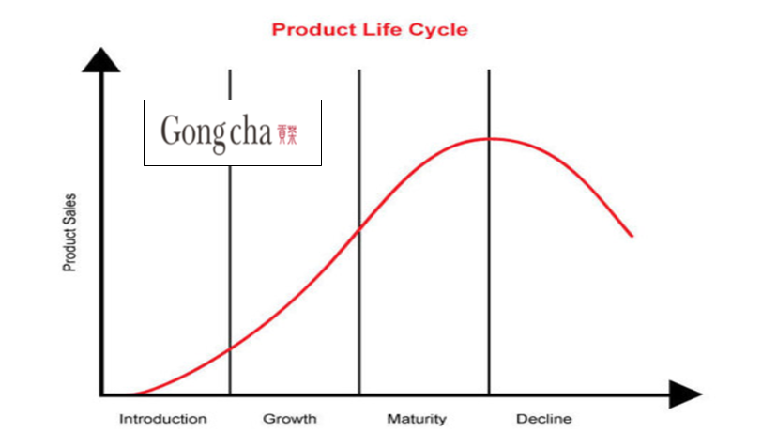

Figure : Gong Cha Product Life Cycle

# Target Market

|  |  |
| --- | --- |
| **Segmentation** | **Description** |
| Demographic | * People live in Singapore ranging from the tourists to local people * Males and females * 15 to 30 years-old * Any marital status and ethnicity * Working professional – students, white-collar workers * Low to middle income * From high school education to graduates |
| Geographic | * Overseas: Hong Kong, Macau, South Korea, New Zealand, Australia, Mainland China. Canada, The United States, Philippines, Myanmar, Vietnam, Brunei * Local: Singapore |
| Psychographic | * Those are adventurous and outgoing, enjoy value time with friends and relatives * Enjoys active or sedentary lifestyle, seek to relax during leisure time * Have interests and hobbies about F&B industry * Have an attitude of taking a break from school or work to rejuvenate themselves. |
| Behavioral | * Take-away products when the outlets are full or they want to wander about the streets. * Enjoy the beverage at the outlets in the air-conditioned room * Those are milk tea addiction |

Figure : Target Market Segmentation

# Timeframe: Gantt Chart

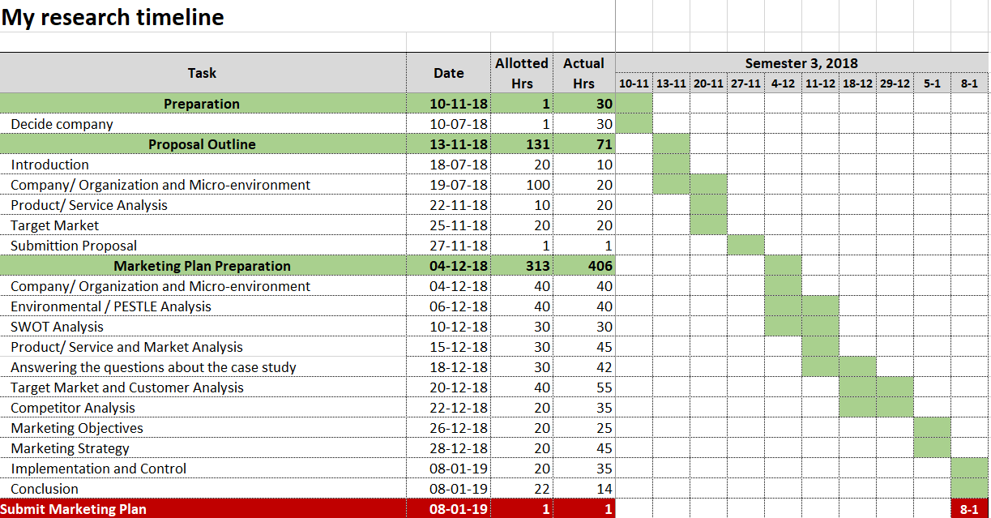

# Conclusion

Gong Cha is one of the famous brand in the bubble tea market in Singapore. In the industry of tea market, there are some noticeable competitors like LiHO, KOI, R&B, which affects the business revenue. Gong Cha positions in the high quality & service and the primary location. It successfully relaunched the business brand in December 2017 after existing in June 2017. Therefore, Gong Cha’s product life cycle is between introduction and growth stage and there are great efforts to boost the business from the perspectives of management level. To increase the business revenue and performance, the firm must invent unique products to attract not only young people but also the elderly, train the staffs’ attitude. This creates the breakthrough in business as well as makes Gong Cha become the leader in the bubble tea market.

**Success! Your submission appears on this page. The submission confirmation number is 22decdb5-527d-4652-978b-6a8b1cbea20e. Copy and save this number as proof of your submission.**[**View all of your submission receipts in My Grades.**](https://learn.jcu.edu.au/webapps/bb-mygrades-BB5a1f6a34a2e8d/myGrades?course_id=_92939_1&stream_name=mygrades&is_stream=false)

**Reference**

About Gong Cha. (2018). Retrieved from <https://www.gongchatea.com.au/about-us/>

About Us. (2018). Retrieved from <http://www.ilovetaimei.com/about-us01/>

About Woobbee. (2018). Retrieved from <http://www.woobbee.qeeple.com/about>

Brand Story. (2018). Retrieved from <http://www.gong-cha-sg.com/about-us/brand-story/>

Liew, E. (2018). *Bubble Tea in Singapore: KOI vs LiHo vs Gong Cha vs TaiGai & More*. Retrieved from <https://blog.moneysmart.sg/dining/bubble-tea-price-koi-liho-gongcha-taigai/>

Mission & Vision. (2018). Retrieved from <http://www.gong-cha-sg.com/about-us/mission-vision/>

News & Events. (2018). *10% Rebate for Ordering from Pre Order Apps (From 7 Nov 2018).* Retrieved from <http://www.gong-cha-sg.com/2018/11/09/10-rebate-for-ordering-from-pre-order-apps-from-7-nov-2018/>

Opening Day Specials. (2017). Retrieved from <http://www.gong-cha-sg.com/2017/11/30/we-are-back-singapore/>

Products. (2018). Retrieved from <http://www.gong-cha-sg.com/products/>

R&B Tea Singapore. (2018). Retrieved from <https://www.facebook.com/rbteasg/>

Tan, R. L. (2017). *Gong Cha's Return Attracts Long Queues*. Retrieved from <https://www.straitstimes.com/lifestyle/food/gong-chas-return-attracts-long-queues>

The Teafolia Story. (2018). Retrieved from <https://www.teafolia.com/about-us/>

The Ultimate Bubble Tea. (2018). Retrieved from <https://bobiifrutii.com.sg/>

Yahya, Y. (2017). *Goodbye Gong Cha, Hello Liho*. Retrieved from <https://www.straitstimes.com/business/companies-markets/goodbye-gong-cha-hello-liho>

Weight Lite. (2018). Retrieved from <http://www.each-a-cup.com/>